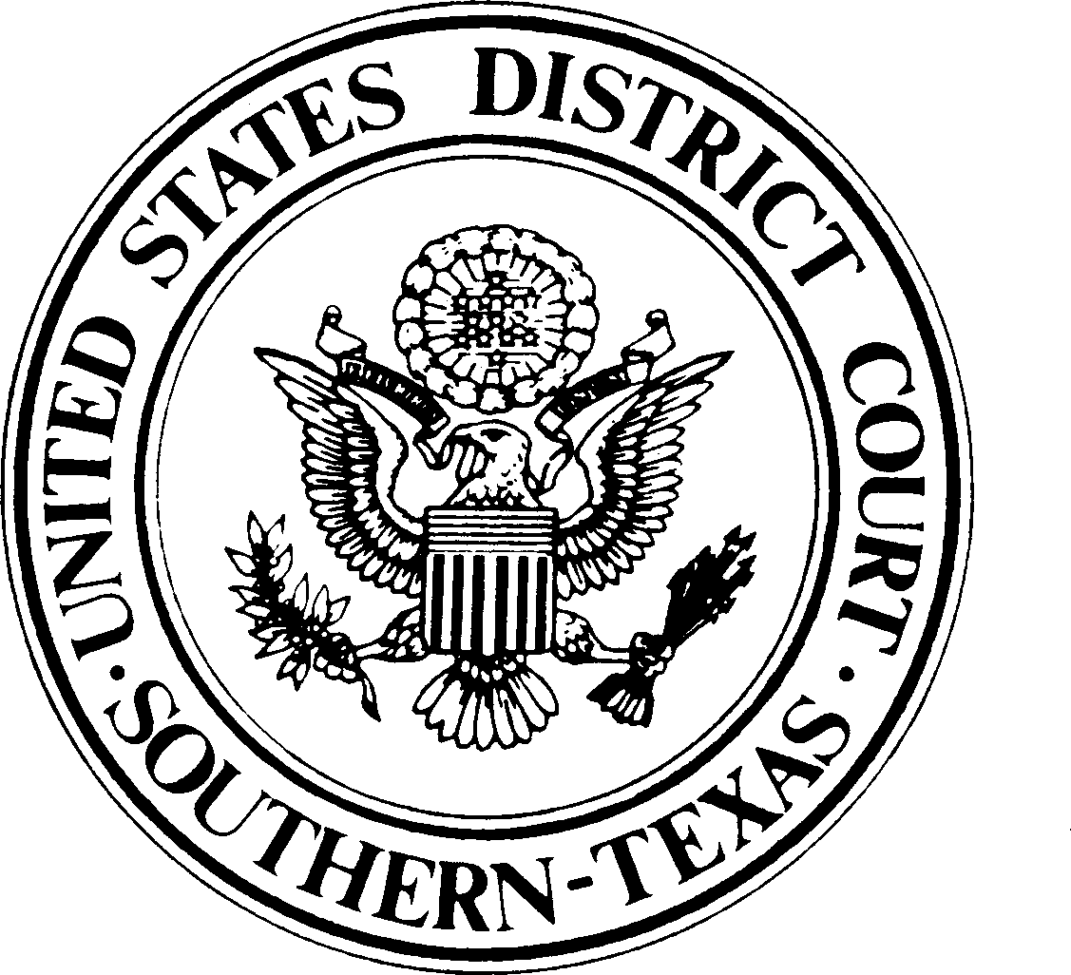

UNITED STATES DISTRICT COURT SOUTHERN DISTRICT OF TEXAS CORPUS CHRISTI DIVISION

UNITED STATES OF AMERICA  VS. | §  §  § | CRIMINAL ACTION
 | § | NO.
 | §

WAIVER OF THIRTY DAYS TO PREPARE FOR TRIAL

Defendant, , accused of

, in violation of Title , United States Code, Section , hereby waives the thirty days to prepare for trial pursuant to Title 18, United States Code, Section 3161(c)(2).

Defendant

Counsel for Defendant

Date:

